Knowledge & Technology



A project report on

**Unmanned Automated Railway Level Crossing System**

A Project Submitted in Partial Fulfillment for the Requirements of the Degree of Bachelor of Science in Information and Communication Engineering.

**Submitted By**

Airin Jahan Akhi

ID: 20105005

**Supervised By**

Md. Nazmul Hussain

Lecturer

Department of ICE, BAUET

Department of Information and Communication Engineering

Bangladesh Army University of Engineering & Technology

April, 2023

Knowledge & Technology

**Department of Information and Communication Engineering**

**Bangladesh Army University of Engineering & Technology**



# DECLARATION

I thereby declare that our project entitled "Unmanned automated railway level crossing system" is the result of my work. I also ensure that it does not previously submit or published elsewhere for the award of any degree or diploma.

The work has been accepted for the degree of Bachelor of Science in Information and Communication Engineering at Bangladesh Army University of Engineering & Technology (BAUET).

**Authors**

……………………..

(Airin Jahan Akhi)

Knowledge & Technology

**Department of Information and Communication Engineering**

**Bangladesh Army University of Engineering & Technology**



# CERTIFICATE

This is to certify that the project entitled "Unmanned automated railway level crossing system" by "Airin Jahan Akhi, ID No.: 20105005” has been accepted as satisfactory in partial fulfilment of the requirement for the degree of Bachelor of Science in Information and Communication Engineering on April, 2023.

Signature of Project Supervisor

……………………………….

Md. Nazmul Hussain

Lecturer

Information and Communication Engineering

Bangladesh Army University of Engineering & Technology

# ACKNOWLEDGEMENT

At first, I would like to pray to Almighty Allah to give me the scope for successful completing our project work.

First and foremost, I would like to thank my supervisor, **Md. Nazmul Hussain** Lecturer, Department of Information and Communication Engineering, Bangladesh Army University of Engineering & Technology. Qadirabad has been a source of tireless and patient guidance, advisement, and knowledge. This project could not be completed without his best directions, advice, and novel ideas,

I would like to thank **Dr. Rubel Basar**, Associate Professor & Head of the Department, Information and Communication Engineering. Bangladesh Army University of Engineering & Technology, Qadirabad for his endless support.

I am very grateful to our respective teachers of the Information and Communication Engineering, Bangladesh Army University of Engineering & Technology, Qadirabad for their valuable suggestions, extending facilitation and inspiration from time to time.

I am cordially thankful to the laboratory staff of the ICE department for their co-operation, and amiable behavior.

Finally, I wish to extend my appreciation and thanks to my family especially to my beloved parents and all my well-wishers for their unconditional love, prayer, and support

Airin Jahan Akhi

ID: 20105005

# LIST OF ABBREVIATIONS

|  |  |  |  |
| --- | --- | --- | --- |
| MCU |  | : | Microcontroller Unit |
| Arduino IDE |  | : | Arduino Integrated Development Environment |
| IR |  | : | Infrared Sensor |
| UART |  | : | Universal Asynchronous Receiver Transmitter |

LED : Light Emitting Diode

DC : Direct Current

**ABSTRACT**

Bangladesh railways have been facing concerns over the increasing number of accidents at level crossings due to the rise in both road and rail traffic. While there are several possible solutions, their feasibility and cost have been major concerns. The aim of this project is to create an automated railway gate system using a microcontroller as the primary component. The primary objective is to design a railway gate that operates automatically by utilizing a microcontroller. The project involves creating a prototype railway gate that integrates with other circuits such as power supply, sonar sensor, servo motor all controlled by the Arduino. This system will improve upon the previous manual operation and may require human supervision in case of any issues during its operation. Overall, the implementation of an automated railway gate system using a microcontroller has the potential to significantly improve the safety and efficiency of railway level crossings in Bangladesh. This project represents an important step towards modernizing railway infrastructure in the country and providing a safer and more reliable transportation system for all.

Table of Contents

DECLARATION i

CERTIFICATE ii

ACKNOWLEDGEMENT iii

LIST OF ABBREVIATIONS iv

List of Figures 1

List of Tables 2

CHAPTER ONE: INTRODUCTION 3

1.1 Introduction 3

1.2 Objectives 4

1.2.2 Specific Objective 5

1.3 Problem Statement 5

1.4 Scope of the study 6

1.5 Limitations 7

CHAPTER TWO: BACKGROUND AND LITERATURE REVIEW 8

2.1 Literature review of the study 8

2.2 System Overview 9

CHAPTER THREE: METHODOLOGY 11

3.1 Methodology of the Study 11

3.1.2 Benefits 12

3.2 System Analysis 13

3.3 Equipment 13

3.3.1 Design and specifications 14

3.4 Design Tools for the Project 14

CHAPTER FOUR: RESULT AND BUDGET 18

4.1 Introduction 18

4.1.1 Images of project 19

4.1.2 Image of Equipment’s 20

4.2 Budget/Finance 22

CHAPTER FIVE: CONCLUSION AND RECOMMENDATIONS 23

5.1 Conclusion 23

REFERENCES 24

# 

# List of Figures

Figure 1.1 Railway Level crossing …………………………………………………………03

Figure 4.1: Railway level crossing system…...………………………………………...…...18

Figure 4.2: Gateman controlled railway level crossing system……………………………..18

Figure 4.3: An automated railway level crossing gate security system……….…………….19

Figure 4.4: Arduino………………………………………………………………………….19

Figure 4.5: Servo Motor………...…………………………………………………………...20

Figure 4.6: Ultrasonic sonar sensor…………….…………………………………………...20

# List of Tables

Table 1: Budget of the project ……………………………………………………………21

# CHAPTER ONE: INTRODUCTION

## Introduction

An automated railway level crossing gate safety system is a critical infrastructure that ensures the safety of both passengers and vehicles crossing the railway tracks. It is designed to prevent accidents at level crossings by automatically lowering and raising the crossing gates when a train is approaching or passing.

The system works by detecting the presence of a train using sensors located near the railway tracks. When a train is detected, the system sends a signal to the crossing gates to lower them, and they remain closed until the train has passed. Once the train has cleared the crossing, the gates are raised again, allowing traffic to resume. It is a technological solution that is designed to enhance the safety of railway level crossings by reducing the risk of accidents between vehicles and trains. This system typically consists of a set of sensors and control mechanisms that work together to detect the approach of trains and activate the crossing gates accordingly.

The system can be divided into two main components: the sensing unit and the control unit. The sensing unit comprises various sensors such as infrared sensors, proximity sensors, and radar sensors that are used to detect presence of an approaching train. The control unit processes the data received from the sensors and activates the crossing gates to stop the

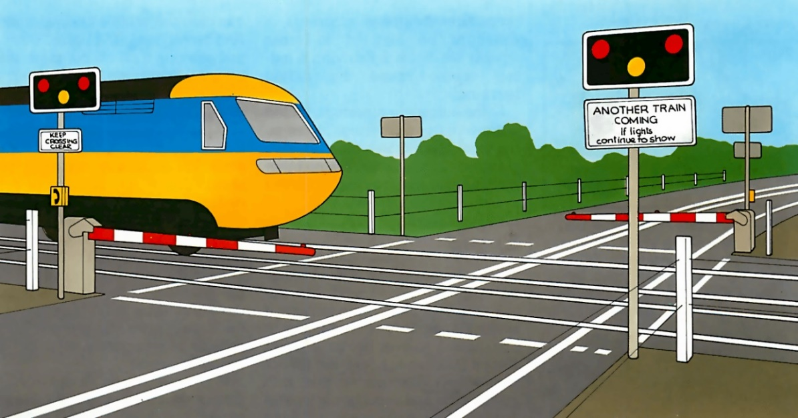

Figure 1.1: Railway Level crossing

In this article, we will discuss the key features and benefits of automated railway level crossing gate safety systems. We will also explore the different types of sensors and technologies used in these systems and how they work. Finally, we will examine the potential drawbacks and limitations of these systems and how they can be overcome.

## 1.2 Objectives

The main objectives of this project are as follows:

1. To create a prototype of a railway gate that can function automatically using a microcontroller: The system detect the presence of a train and it also control gate to ensure that the level crossing is safe. Once the train has passed through the level crossing, the gate is opened. This system is designed to improve the safety and efficiency of level crossings, which are critical points on railway networks where trains and road vehicles intersect in unmanned area
2. To avoid unusual accident: A level crossing is a location where a railway track intersects with a highway or road at the same level. This means that vehicles and pedestrians need to cross the railway track, which can pose a safety risk if not managed properly. According to a news report from Dhaka Tribune in 2020, more than 400 people died in railway accidents in Bangladesh in that year alone, and many of these accidents occurred at railway gate crossings. This is mainly due to the carelessness in manual operations or lack of workers at level crossing. That’s why we design this system which is fully automated.
3. To reduce cost: If we want to secure every railway level crossing, Then each crossing has to hire one person and have to pay a certain amount of salary to them in every month. But if we execute this automatic system in unmanned area, there will be invest a certain amount of money at a time and it will be cost effective and also all area will be secure there will no risk.

Moreover, the purpose of this project is to replace gatekeepers with an automated system in unmanned area. The implementation of an interfacing program structure is intended to provide numerous benefits.

### 1.2.2 Specific Objective

* To design an automatic railway gate control system using a microcontroller.
* To develop an interfacing program to integrate the microcontroller's operations.
* To reduce the manual working process.
* To reduce human salary related cost
* To secure all unmanned railway level crossing
* To reduce unexpected death by railway accident.

## 1.3 Problem Statement

Currently, railway gates are operated manually, particularly at railway line junctions with roads, where gatekeepers must be employed to control gate operations. Workers have to manually open and close the gate under supervision. But some areas there is no gateman to secure the level crossing and that's where the accident happened.

The prototype system introduces automatic railway gate operation, which improves upon the previous manual operation. However, human supervision is still necessary in case of any issues during the system's operation.

The project involves integrating computer technology with mechanical structures to simulate the system's capabilities. The incorporation of computer applications into the control system can enhance the efficiency of railway gate management for both management and consumers. Therefore, this project serves as a prime example of how to develop a more efficient railway gate management system.

1. Human error: The manual operation of railway gate crossings is prone to human error, such as forgetting to close the gates, opening the gates too early, or failing to detect an approaching train. These errors can lead to serious accidents and fatalities.
2. Lack of coordination: Manual gate operation requires coordination between gatekeepers and train operators, which can be challenging, especially in situations where there are multiple level crossings or complex train schedules. This lack of coordination can lead to confusion, delays, and accidents.
3. Delayed response time: Manual gate operation is often slower than automatic systems, which can result in longer response times to close the gates when a train is approaching. This delay can increase the risk of accidents and collisions.

## 1.4 Scope of the study

This project involves the use of a microcontroller to control the operation of an automatic railway gate. The various circuits involved, such as power supply, sonar sensor, motor and Arduino are combined to demonstrate the microcontroller's operation. The circuits are designed and tested on Proteus software before being implemented in hardware. The sensor circuit triggers the Arduino, which then activates the gate motor. The system is flexible enough to allow for the addition of extra components without affecting the existing ones.

Some possible areas of focus for such a study might include:

Technical design and implementation: This area of study would focus on the technical design and implementation of an automated railway level crossing gate system, including the hardware and software components of the system, the types of sensors and control mechanisms used, and the communication networks and data logging systems that are in place.

Safety and risk assessment: Another area of study might focus on the safety and risk assessment of automated railway level crossing gate systems. This would include an analysis of the potential risks and hazards associated with such systems, as well as an evaluation of the safety measures and protocols that are in place to mitigate those risks.

Effectiveness and efficiency: A study could also examine the effectiveness and efficiency of an automated railway level crossing gate system, including its impact on reducing accidents and fatalities, reducing delays and improving the overall speed and reliability of rail transportation.

Cost-benefit analysis: Another important aspect of a study on automated railway level crossing gate systems could be a cost-benefit analysis, which would examine the costs associated with implementing and maintaining such a system, as well as the potential benefits in terms of improved safety, reduced delays, and improved efficiency of rail transportation.

Policy and regulatory considerations: Finally, a study on automated railway level crossing gate systems could also examine the policy and regulatory considerations associated with such systems, including the legal and regulatory frameworks that govern their use, as well as the ethical and social implications of their deployment.

Overall, the scope of a study on automated railway level crossing gate systems can be broad and multifaceted, encompassing a range of technical, safety, effectiveness, efficiency, cost-benefit, and policy considerations.

## 1.5 Limitations

Automated railway level crossing gate safety systems have greatly improved railway safety by reducing accidents and fatalities caused by trains colliding with vehicles or pedestrians at level crossings. However, there are several limitations to these systems that need to be considered. Here are some of them:

1. Cost: Implementing an automated railway level crossing gate safety system can be expensive, especially for railways with a large number of level crossings. This can make it difficult for smaller railways or railways in developing countries to implement these systems.
2. Maintenance: These systems require regular maintenance to ensure they are functioning properly. If maintenance is neglected, the system may malfunction, leading to accidents.
3. Power supply: These systems require a reliable power supply to function properly. If there is a power outage or a power supply disruption, the system may not work correctly, which can lead to accidents.
4. False alarms: These systems can sometimes trigger false alarms, which can lead to inconvenience and delays for railway users.

Overall, while automated railway level crossing gate safety systems have many benefits, they are not without their limitations. Railway operators need to consider these limitations when implementing these systems and take steps to address them to ensure they function safely and effectively.

# CHAPTER TWO: BACKGROUND AND LITERATURE REVIEW

## 2.1 Literature review of the study

This paper proposes a model to manage the control system of railway gates using a microcontroller to prevent accidents at unmanned railway crossings. Two powerful magnetic sensors are fixed on either side of the gate - one on the upside and the other on the downside of the train direction. The foreside sensor detects the approaching train and sends a signal to the microcontroller, which closes the gate and keeps it closed until the train reaches the after-side sensor. When the after-side sensor is activated, the microcontroller receives a signal indicating the departure of the train, causing the motor to turn in the opposite direction, opening the gate and stopping the motor.[1]

The aim of this work is to automate the opening and closing of gates at railway level crossings, which are typically operated by a gatekeeper. The proposed system uses infrared sensors and an Arduino to detect the arrival and departure of trains, and to control the opening and closing of gates. When the train arrives, signals are sent to indicate its presence, and when the second sensor detects the train, the gate closes. The gate remains closed until the train has fully crossed the level crossing, and when the departure of the train is detected by the third sensor, the gate opens and traffic signals turn green. By automating gate operations using sensors, the need for human intervention can be eliminated, and traffic congestion near the crossing can be reduced.[2]

M. M. Eid et.al. has main objectives are to provide an efficient alternative to many conventional techniques which could be lately applied on a large scale. The proposed system is designed to integrally achieve some tasks are like avoiding railway accidents, detecting obstacles, improve train visibility, controlling crossing gate, alarming system for fire detection. They used railway gate, level crossing, infrared sensor, track switching, train control unit, crack detection.[3]

P. Ilampiray et.al. has used ultrasonic sensors for detecting the departure and arrival of the trains. As soon as possible the sensor senses the trains arrival it sends a message to the Arduino which will switch on the buzzer, that’s why road users will know that the train is nearer and then the servo motor which is attached to the gates will close and it will open after the train passes by. They used Arduino, Ultrasonic sensor, servo motor, buzzer.[4]

Level crossing accidents are a major problem in third world countries due to the lack of warning systems and other factors. Developed countries have more advanced solutions, but they are not affordable for developing countries. To address this, a cost-effective system called the Automatic Rail Crossing Alarming System has been developed to run on solar power with low power consumption, providing an effective warning for road users during train arrivals to reduce accidents in level crossings.[5]

M. I. M. Amjath et.al. has proposed a system consists of two subsystems, the tarin detection subsystem and level crossing sub system, and uses vibration and inductive proximity sensors for train detection and image processing and machine learning algorithms for vehicle detection. The system also employes AES algorithm for secure data transmission between subsystems through RF communication. The proposed model is expected to reduce the occurrence of fatal accidents and contribute to a country’s economy.[6]

R. Iqbal et.al has shown a low-cost and power-efficient railway crossing system using ZigBee communication to automate railway crossings and prevent accidents in developing countries where human resources are required to manually operate the gates. The use of ZigBee wireless modules is proposed due to their inexpensive and energy-efficient nature. The effectiveness of ZigBee communication in outdoor environments has been tested and proven reliable for data delivery [7]

## 2.2 System Overview

Sensor based railway gate automation system is developed to automate the process of opening and closing of gate at the railway level crosses. The system detects the arrival and the departure of train for the gate operation using different types of sensors. The proposed system uses three infrared sensors to identify the arrival and departure of trains. The system also implements obstacle sensor which detects any obstacle on the track and controls the operation of the train. Sensors and servo motors are programmed using Arduino micro-controller. The major components used in the automation of railway gate at the level gates are sensors. Sensors that detect the train can be classified into different types such as:

Detecting sensor: Ultrasonic sensors works on magnetic inductive principle. The DC current

which is generated as the output signal from the wheel detectors are used for the detection of train arrival. That detects the arrival and departure of the train.

Gate controlling motor: Servo motor are works on the gate controlling system Overall, using a servo motor to control the gate in an Arduino-based automated railway level crossing gate safety system provides a precise and reliable method of controlling the gate position.

# CHAPTER THREE: METHODOLOGY

## 3.1 Methodology of the Study

The methodology for an Arduino-based automated railway level crossing gate safety system typically involves the following steps:

1. Designing the circuit: The first step is to design the circuit for the system. This involves identifying the necessary components and wiring them together in a way that allows the system to function properly. The components typically include an Arduino microcontroller, sensors to detect trains and cars, a motor to control the gate, and other necessary electronics.
2. Programming the Arduino: The next step is to program the Arduino microcontroller to control the system. This involves writing code that will allow the microcontroller to receive input from the sensors, make decisions based on that input, and control the gate accordingly. The code may also include other features, such as alarm systems or communication with external devices.
3. Testing and debugging: After the circuit is designed and the Arduino is programmed, the system needs to be tested to ensure that it functions properly. This involves testing the sensors, motor, and other components to ensure that they are working correctly, as well as testing the code to ensure that it is responding to the input from the sensors as expected. Any bugs or errors in the system must be identified and corrected.
4. Implementation: Once the system has been designed, programmed, and tested, it can be implemented at the railway level crossing. This involves installing the sensors, motor, and other components, as well as connecting the system to the power supply and any external devices. The system should be tested again after implementation to ensure that it is functioning properly in its actual environment.

Overall, an Arduino-based automated railway level crossing gate safety system involves designing a circuit, programming the Arduino microcontroller, testing and debugging the system, and implementing it at the railway level crossing. The goal of the system is to ensure that trains and cars can safely cross the railway level crossing without risking collision or other accidents.

The basic steps of system designing:

* System Analysis
* System Design.
* Implementation

### 3.1.2 Benefits

The Arduino-based automated railway level crossing gate safety system offers several benefits, including:

1. Improved safety: The system helps to ensure the safety of both passengers and railway workers by automatically detecting the presence of trains and lowering the level crossing gate accordingly. This reduces the risk of accidents caused by human error, such as forgetting to close the gate or misjudging the speed of an approaching train.
2. Reduced waiting times: The system can be programmed to detect the approach of a train and adjust the gate accordingly, reducing the time that motorists and pedestrians need to wait at the crossing. This can help to improve traffic flow and reduce congestion in the area.
3. Cost-effective: Arduino-based systems are relatively inexpensive and easy to install, making them a cost-effective solution for improving railway safety.
4. Customizable: The system can be customized to meet the specific needs of a particular railway crossing, allowing it to be adapted to a range of different conditions and requirements.
5. Real-time monitoring: The system can be equipped with sensors that monitor the status of the gate and provide real-time feedback to operators or maintenance personnel. This allows them to quickly identify and address any issues with the system, reducing downtime and improving overall reliability.

Overall, an Arduino-based automated railway level crossing gate safety system offers a range of benefits that can help to improve safety, reduce waiting times, and lower costs for railway operators.

## 3.2 System Analysis

A system analysis of an Arduino-based automated railway level crossing gate safety system would involve examining the various components and subsystems that make up the system, as well as the interactions between these components. The following is a general overview of the key elements of such a system:

Arduino board: The Arduino board is the heart of the system, and it controls the various functions of the system. The board receives input from various sensors, processes the data, and sends output signals to control the railway level crossing gate.

Sensors: The system would require several sensors to detect the presence of a train and other environmental factors. These could include a train detection sensor, which could be based on infrared, ultrasonic or magnetic technology, and a sensor to detect the position of the railway gate.

Motor: The system would also require a motor to control the operation of the railway gate. These could include a servo motor to operate the gate, as well as lights and warning signals to alert drivers and pedestrians.

Power supply: The system would require a reliable power supply, which could be provided by a battery or a mains power supply. The power supply would need to be capable of delivering enough power to operate the various components of the system.

Software: The Arduino board would require software to control the various components of the system. The software would need to be designed to receive input from the sensors, process the data, and send output signals to the actuators.

Overall, the system analysis of an Arduino-based automated railway level crossing gate safety system would involve examining the various components and subsystems that make up the system, as well as the interactions between these components. The goal would be to ensure that the system is designed to operate reliably and safely, and to minimize the risk of accidents or malfunctions.

## 3.3 Equipment

A railway level crossing gate safety system based on an Arduino microcontroller can be designed and specified as follows:

**Hardware components:**

1. Arduino Uno or Mega board
2. Ultrasonic sensors to detect the approaching train
3. Servo motor to control the opening and closing of the gate

**Software:**

1. Arduino IDE to program the microcontroller
2. Libraries for ultrasonic sensor and servo motor control

### 3.3.1 Design and specifications

The ultrasonic sensors will be placed at a distance from the railway tracks to detect the approaching train. Once the sensors detect the train, the Arduino board will send a signal to the servo motor to close the gate.

The gate will remain closed until the train has passed and the sensors no longer detect its presence. Once the train has passed, the Arduino board will send a signal to the servo motor to open the gate.

Overall, this automated railway level crossing gate safety system based on an Arduino microcontroller can help improve safety at level crossings and reduce the risk of accidents.

## 3.4 Design Tools for the Project

The technologies/tools that will be used for this work are as follows:

**Arduino:**

Arduino is an open-source electronics platform based on easy-to-use hardware and software that can be used to create interactive electronic projects. It consists of a microcontroller board, software development environment, and a community of users and developers who share ideas and knowledge.

The microcontroller board is the heart of the Arduino platform, and it comes in several different types with varying capabilities. The most popular board is the Arduino Uno, which is based on the Atmega328P microcontroller and includes a USB interface for programming and communication.

The software development environment includes an integrated development environment (IDE) that allows users to write, compile, and upload code to the microcontroller board. The code is written in the Arduino programming language, which is based on the C and C++. Its ease of use and open-source nature make it an attractive option for hobbyists, students, and professionals alike.

**Sensor:**

Sensor that detects an object, an ultrasonic sonar sensor is a type of sensor that uses sound waves to detect the distance between the sensor and an object. It works by sending out a high-frequency sound wave and measuring the time it takes for the sound wave to bounce back after hitting an object. The sensor then calculates the distance based on the time it took for the sound wave to travel back.

Ultrasonic sonar sensors are commonly used in robotics and automation applications for detecting obstacles and measuring distances. They are particularly useful in applications where other types of sensors, such as infrared sensors, may not work well due to factors such as ambient light or surface reflectivity. They can be used in combination with other sensors and control systems to automate processes and improve efficiency.

**Motor:**

A servo motor is a type of motor that is commonly used in robotics, automation, and other control applications. It is a rotary actuator that allows for precise control of angular position, velocity, and acceleration.

Servo motors are designed to be controlled by a feedback signal, typically in the form of a pulse width modulation (PWM) signal. The PWM signal provides a series of pulses that determine the desired position of the servo motor. The servo motor then uses its internal feedback mechanism to adjust its position to match the desired position.

One of the key features of servo motors is their ability to maintain their position even when external forces are applied. This is accomplished through the use of a closed-loop control system that constantly monitors the position of the motor and makes adjustments as necessary to maintain the desired position. Servo motors are commonly used in robotics applications for controlling the position of robot joints and other mechanical systems. They are also used in industrial automation for controlling the position of machine components, such as conveyor belts or robotic arms.

In addition to their precision and accuracy, servo motors are also known for their high torque and fast response times, making them a popular choice for applications that require quick and precise movements.

**Arduino IDE:**

The Arduino Integrated Development Environment (IDE) is a software platform used to write, compile and upload code to Arduino microcontroller boards. It is a cross-platform application that runs on Windows, Mac OS X, and Linux.

The Arduino IDE provides a user-friendly interface for programming Arduino boards, making it easy for beginners to get started with the platform. The IDE includes a code editor, a compiler, a serial monitor for debugging, and a variety of libraries and examples to help users get started. The code editor in the Arduino IDE supports syntax highlighting, auto-completion, and other features to make writing code faster and more efficient. The compiler in the IDE translates the code into machine language that can be executed by the microcontroller board.

The serial monitor is a useful tool for debugging Arduino programs. It allows users to view messages sent by the microcontroller board and send messages back to the board for testing and debugging. The Arduino IDE also includes a library manager that makes it easy to add third-party libraries to your Arduino projects. Libraries provide pre-written code for common functions, such as controlling a servo motor or reading data from a sensor.

Overall, the Arduino IDE provides a simple and user-friendly way to program Arduino boards, making it accessible to beginners and experienced users alike.

**Libraries for sensor and motor:**

An ultrasonic sensor is a type of sensor that uses sound waves to detect the distance between the sensor and an object. It works by emitting high-frequency sound waves and then measuring the time it takes for the waves to bounce back after hitting an object. This information can be used to calculate the distance between the sensor and the object.

The Arduino IDE includes a built-in library for working with ultrasonic sensors, called the NewPing library. This library provides a simple interface for controlling ultrasonic sensors and reading their output. It includes functions for measuring distance in centimeters or inches, and for handling multiple sensors at once.

On the other hand, a servo motor is a type of motor that can rotate to specific angles based on input signals. It is commonly used in robotics and other applications where precise control of movement is required.

The Arduino IDE includes a built-in library for working with servo motors, called the Servo library. This library provides a simple interface for controlling servo motors using PWM (pulse width modulation) signals. It includes functions for setting the position of the servo motor based on angle or pulse width, and for handling multiple servo motors at once. Both the NewPing library for ultrasonic sensors and the Servo library for servo motors are easy to use and provide a simple interface for controlling these components. They are widely used in Arduino projects and can help simplify the process of working with these sensors and motors.

# CHAPTER FOUR: RESULT AND BUDGET

## 4.1 Introduction

The results of an automated railway level crossing system can be very positive in terms of improving safety and efficiency at railway crossings. By automating the process of opening and closing barriers at railway level crossings, these systems can help to prevent accidents and reduce delays caused by trains having to slow down or stop at crossings.

Studies have shown that automated railway level crossing systems can significantly reduce the number of accidents and fatalities at railway crossings, particularly in areas with heavy road traffic. By providing warning signals and closing the barriers automatically, these systems can help to prevent collisions between vehicles and trains, as well as reducing the risk of pedestrians crossing the tracks when a train is approaching.

In addition to improving safety, automated railway level crossing systems can also help to improve the efficiency of train operations. By reducing the need for trains to slow down or stop at crossings, these systems can help to reduce delays and improve the overall speed and reliability of rail transportation.

Overall, the results of an automated railway level crossing system can be very positive, helping to improve safety and efficiency at railway crossings and contributing to a safer and more efficient transportation system.

### Images of project

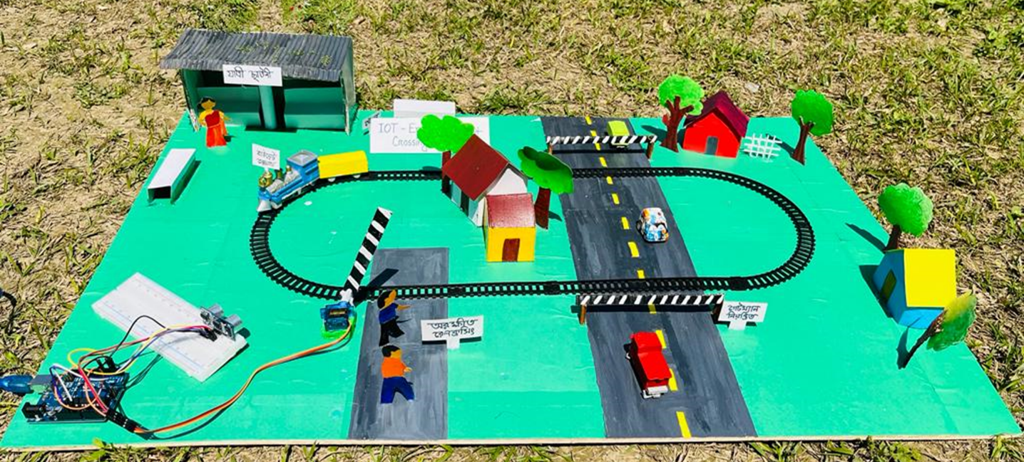

Figure 4.1: Railway level crossing system

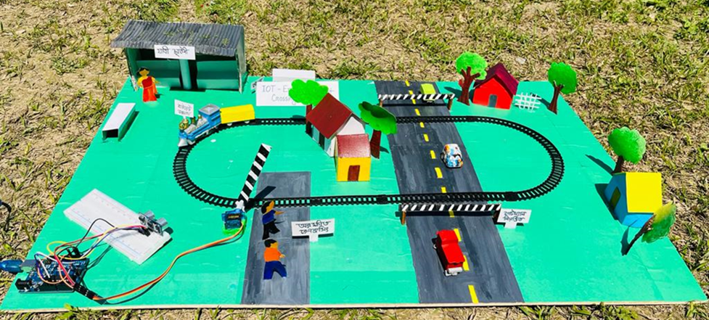

Figure 4.2: Gateman controlled railway level crossing system

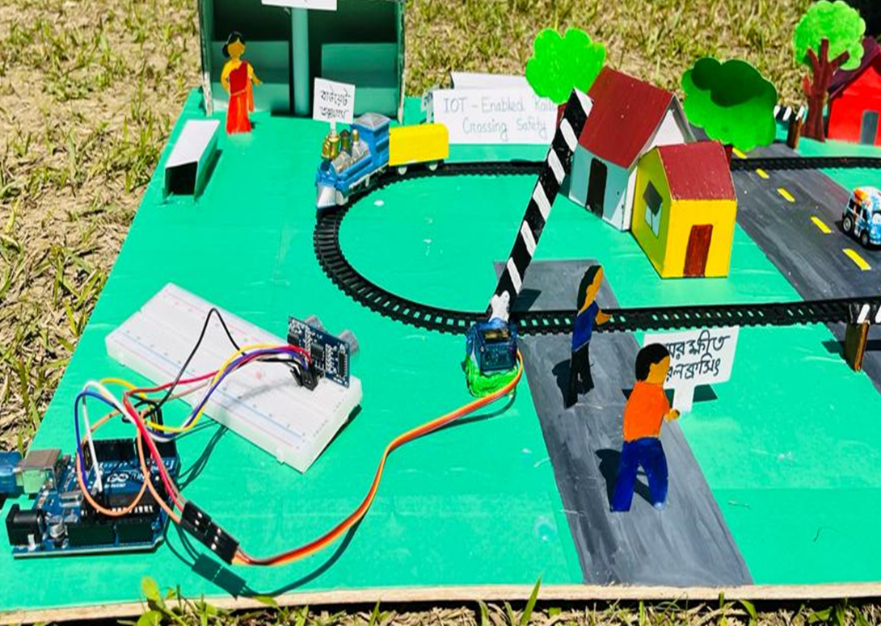

Figure 4.3: An automated railway level crossing gate security system

## Image of Equipment’s

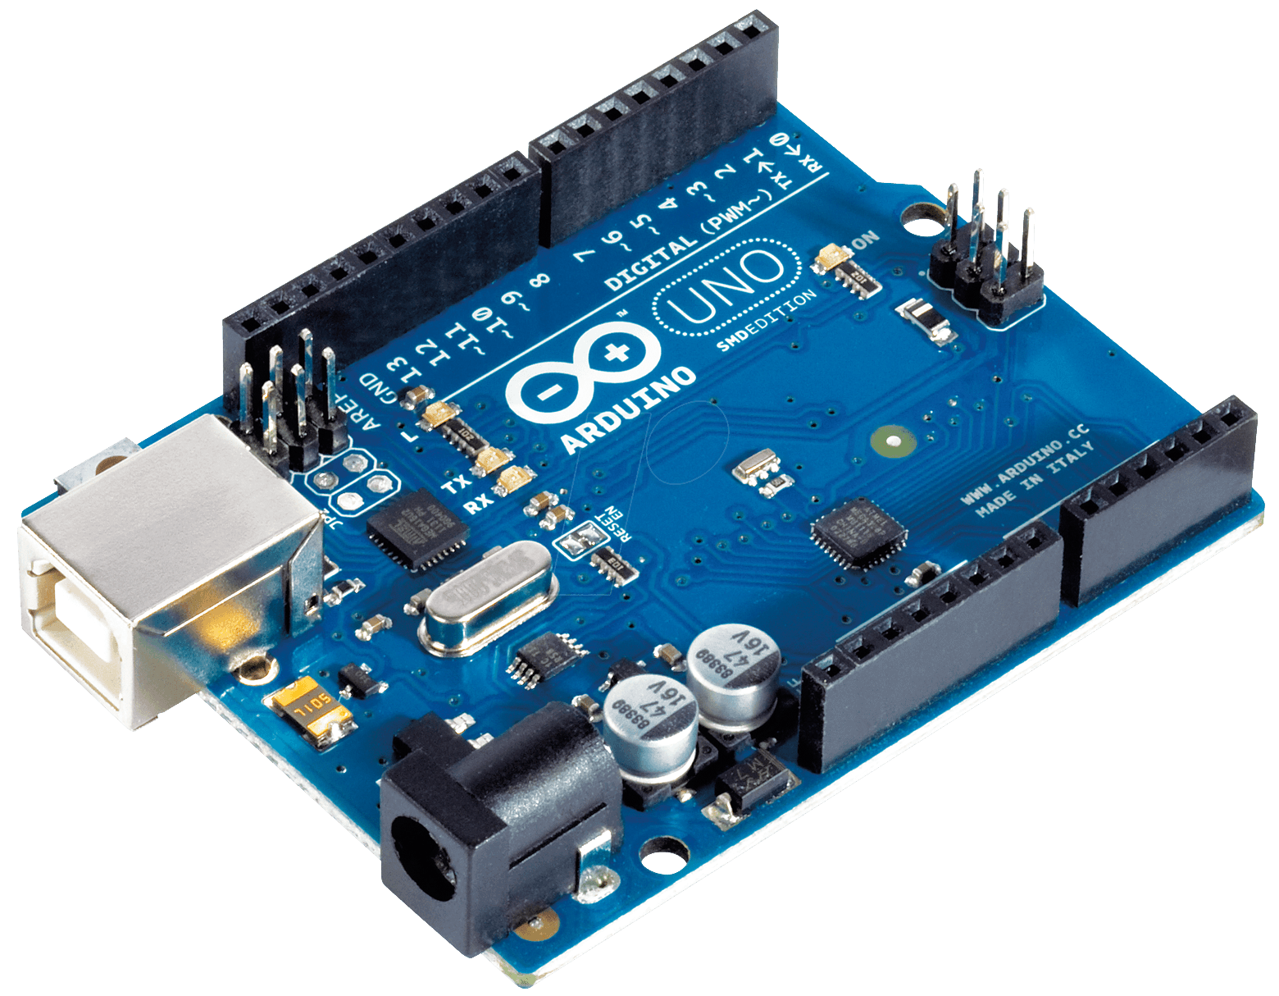

Figure 4.4: Arduino

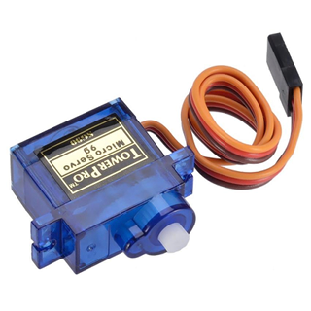

Figure 4.5: Servo Motor

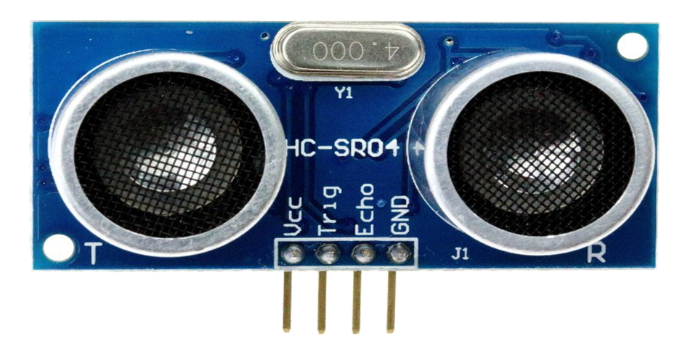

Figure 4.6: Ultrasonic Sonar Sensor

## Budget/Finance

|  |  |  |  |
| --- | --- | --- | --- |
| No. | Material | Amount | Cost |
| 1 | Arduino | 1 | 900/- |
| 2 | Ultrasonic Sensor | 1 | 90/- |
| 3 | Servo Motor | 1 | 150/- |
| Total |  |  | 1140/- |

Table-1: Budget of the project

# CHAPTER FIVE: CONCLUSION AND RECOMMENDATIONS

## 5.1 Conclusion

An Automated railway level crossing gate system is an important technology that can significantly improve safety and efficiency at railway crossings. By automating the process of opening and closing barriers, these systems can help to prevent accidents and reduce delays caused by trains having to slow down or stop at crossings.

The use of sensors, control mechanisms, and communication networks in automated railway level crossing gate systems allows for the automatic detection of approaching trains and the activation of warning signals and barriers to prevent vehicles and pedestrians from crossing the tracks. This can greatly reduce the risk of collisions between vehicles and trains, as well as improving safety for pedestrians and other road users.

Moreover, automated railway level crossing gate systems can also improve the efficiency of train operations by reducing delays and improving the overall speed and reliability of rail transportation.

However, it is important to note that the installation and maintenance of these systems can be expensive and require ongoing investment. Furthermore, there may still be instances of human error or malfunction that can lead to accidents or delays.

Overall, the benefits of automated railway level crossing gate systems make them a valuable addition to railway safety infrastructure, but continued monitoring and investment is necessary to ensure their ongoing effectiveness and reliability.

# REFERENCES

[1] A. S. M. Al-Zuhairi, “Automatic Railway Gate and Crossing Control based Sensors & Microcontroller,” Int. J. Comput. Trends Technol., vol. 4, no. 7, 2013.

[2] K. Krishnamurthi and M. Bobby, “Sensor based automatic control of railway gates,” vol. 4, no. 2, 2015.

[3] M. M. Eid and M. I. Fath Allah, “Automated Railway Security System,” in 2019 6th International Conference on Advanced Control Circuits and Systems (ACCS) & 2019 5th International Conference on New Paradigms in Electronics & information Technology (PEIT), Nov. 2019, pp. 54–64. doi: 10.1109/ACCS-PEIT48329.2019.9062886.

[4] P. Ilampiray, K. Deepak, M. G. D. Santhosh, and S. kishore, “Automated Railway gate control system using Arduino and Ultrasonic sensors,” J. Phys. Conf. Ser., vol. 1916, no. 1, p. 012081, May 2021, doi: 10.1088/1742-6596/1916/1/012081.

[5] S. Mahmud, I. Emon, and M. Billah, “Automated Railway Gate Controlling System,” Int. J. Comput. Trends Technol., vol. 27, pp. 1–5, Sep. 2015, doi: 10.14445/22312803/IJCTT-V27P101.

[6] K. Suresh, “Automatic Railway Gate Level Control System,” vol. 5, no. 0972, 2018.

[7] D. Rajan, “Automatic Railway Gate Control System Using Arduino Controller,” In Review, preprint, May 2021. doi: 10.21203/rs.3.rs-529956/v1.

[8] M. Alam, “Automatic level crossing system,” Nov. 2015.

[9] S. Tejaswini, G. Komal, W. Nayan, and A. R. Kadu, “Automatic Railway Train Safety System,” vol. 4, no. 9.

[10] S. Agrawal et al., “An Arduino based Method for Detecting Cracks and Obstacles in Railway Tracks,” 2018.

[11] N. L. Bhojwani, A. S. Ansari, S. S. Jirge, M. B. Baviskar, and D. N. Pawar, “RAILWAY TRACK – CRACK DETECTION SYSTEM BY USING ARDUINO MICROCONTROLLER,” Int. J. Eng. Appl. Sci. Technol., vol. 6, no. 5, Sep. 2021, doi: 10.33564/IJEAST.2021.v06i05.044.

[12] O. Ikpeze, E. Uwaezuoke, S. Bola-Matanmi, and K. Kareem, “Design and Construction of an Automatic Gate,” vol. 2, pp. 123–131, Oct. 2021.

[13] S. U. Zaman, S. Hossairr, and C. Shahnaz, “Automatic Rail Crossing Alarming System,” in 2018 IEEE International WIE Conference on Electrical and Computer Engineering (WIECON-ECE), Dec. 2018, pp. 129–132. doi: 10.1109/WIECON-ECE.2018.8783140.

[14] M. I. M. Amjath and T. Kartheeswaran, “An Automated Railway Level Crossing System,” in 2020 International Conference on Image Processing and Robotics (ICIP), Mar. 2020, pp. 1–7. doi: 10.1109/ICIP48927.2020.9367346.